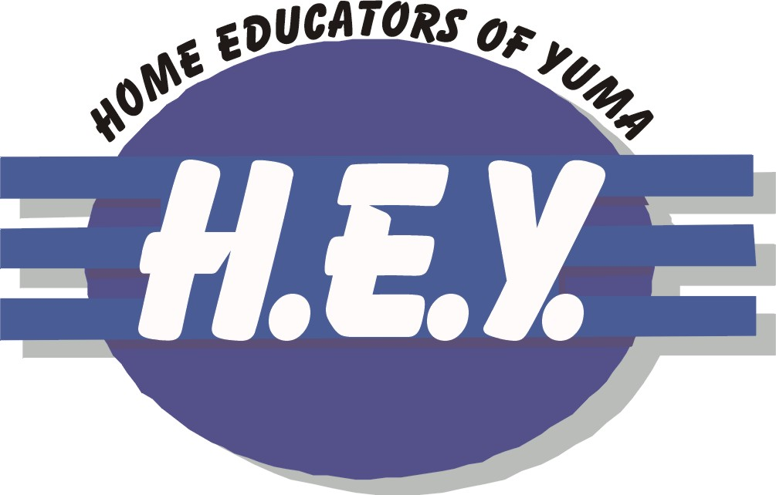

We are a Christian homeschool support group that provides an opportunity for fellowship and support of home schooled families in a wholesome Christian atmosphere.

We meet regularly from September through May for fun, encouragement and field trips. We also share curriculum information and develop friendships.

For more information,
check out our website at
www.homeeducatorsofyuma.com
or contact Nicole Haney at 317-2737

